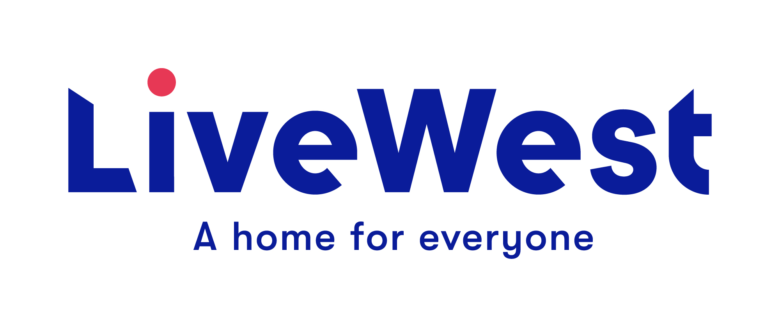
LiveWest supporting communities grant application form for groups and organisations
for grants of up to £1,000

The aim of LiveWest supporting communities grants is to enable groups and organisations to make positive differences to LiveWest communities and the lives of LiveWest customers.

Grants are to cover specific costs or needs of groups and organisations. Applicants must demonstrate how projects or initiatives will provide specific benefits or services for LiveWest customers and explain how they will engage and target the individuals or groups they are looking to support. Please also refer to the application guidance notes.

- Name and contact details of applicant:

Name of group/organisation:

Address:

Contact Number:

Email address:

Name of person completing this form and your position in the group:
Name of LiveWest member of staff completing form (if applicable):

- Purpose of the funding – Please explain what you will use the funding for:

- Amount applied for:
Please explain how much you are applying for and list specific items and costs.  Include full details and breakdown of costs for each item/service listed. | Item/service Cost  £  £  £  £  Total £
Bank Details:  If your application is approved, we will usually send payment by BACS transfer. | Account Name:  Account Number:  Sort Code:  Name and phone number of organisational contact we can verify bank details with:

- Details of your organisation or group – How long has it been running, what is its core work, and does it have a history of working with LiveWest?
☐ Residents Association ☐ Registered Charity
☐ Informal LiveWest customer group ☐ Limited Company
☐ Community group ☐ Other
☐ Community Interest Company

Registered number if applicable_______________________
Information about your group:

5 Where will the project, activity or event take place and how will it include LiveWest customers? How many people do you expect it to benefit and what proportion of those will be LiveWest customers? Is your project targeted at any specific age range or group?

6 How have you identified the need for your project? If anyone else is running a similar project locally, how will you work with them to compliment your work or prevent duplication?

7 Please explain any other funding you have received:

8 Please provide any other information relevant to your application:

9 It is essential that we target our support to benefit LiveWest customers.
Please can you explain how you will monitor and record customer numbers and feedback, measure the impact of your work and report on how the grant has specifically benefited LiveWest customers?

Please email completed applications to - grants@livewest.co.uk

General Data Protection Regulation

LiveWest is subject to the requirements of The General Data Protection Regulation, please see our website for our current Privacy notice.

By signing this proposal form, you agree to the following:

1. We will use this application form and the other information you give us for the following purposes only:
- To decide whether to support your activity or project with LiveWest funding
- To hold in our database and use for statistical purposes and future monitoring of the project.
- By writing your name on this form and submitting it to LiveWest, we can take this as consent for us to hold the data provided and use it for the purpose it was given.

2. LiveWest reserve the right to withdraw any application

In submitting this application, you confirm that, to the best of your knowledge, the information provided on this form is correct and you confirm that any grant awarded will be used exclusively for the purposes described.

Signed____________________________________________________

Date____________________________

