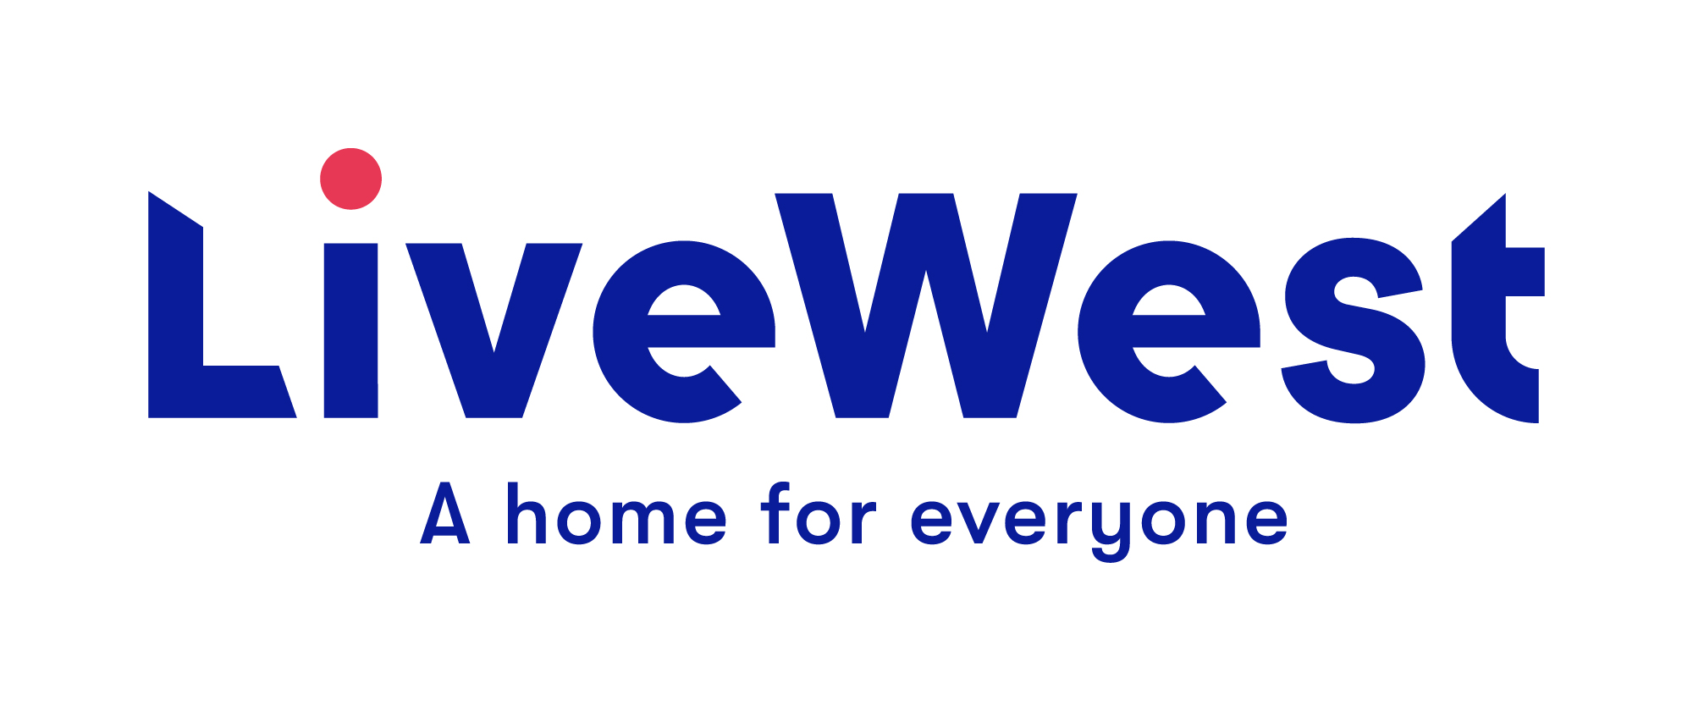
LiveWest Opportunity Fund Application Form
for Individuals

This application form is for grants of up to £500.
Improvement Fund - Application
The LiveWest Opportunity Fund is for LiveWest customers only and aims to support individuals improve their employment and education prospects, health and wellbeing or personal development.

- Name and contact details of applicant:

Customer Name:

Address:

Contact Number:

Email address:

LiveWest Member of Staff:
Name of staff member supporting this application. Job title, location and team

- Have you previously applied to LiveWest for any grant funding?
If so when did you apply and what was the outcome?

3 Purpose of the funding - Please explain what you will use the funding for.

4 When do you propose to use the funding if successful? E.g. when is the course start date?

- What difference will the money make to you and your future?
For example: How will the training course enable you to find employment?

6 Costings:

Please provide details on the costings and attach any supporting evidence
Please note that if your application is successful LiveWest will require copies of receipts in relation to these costs. We will pay suppliers direct where possible.
LiveWest will award a maximum of £250 for laptops.
Item | Cost
 | £
 | £
 | £
 | £
 | £
Total funding being applied for from LiveWest | £
Any other funding or contributions from other sources | £
Total funding overall | £

7 Grants for training courses:

Please provide details of the course provider (name of course, dates, and contact information for invoicing).

8 What steps have you taken to achieve your goals outside of LiveWest funding? Have you attempted to gain funding from other sources, if so where and what is the result? Have you undertaken other training or related courses? Please explain any related activity or preparatory work.

9 Summary:
Please provide any additional information to support your application.

10 Local Authority: Please state which Local Authority area you live in

11 Your current employment status:

12 Income/ Expenditure: Please provide details of your monthly household income and expenditure.

Income | £ | Expenditure | £
Applicant wages |  | Rent/ Mortgage
Partner wages (if applicable) |  | Council Tax
Universal Credit (UC) |  | Water
ESA |  | Gas
JSA |  | Electricity
Child Tax Credit |  | TV Licence
Working Tax Credit |  | Housekeeping
DLA/AA/PIP |  | TV/Phone
Child Benefit |  | Other expenditure
Income Support
Housing Benefit
Income from non-dependents
Other income
Total | £ | Total | £

Savings/Income Do you have savings above £500? (Yes / No)
To assess eligibility, we will discuss your financial circumstances and may require you to prove you do not have savings above £500.

13 If a LiveWest member of staff is completing this application on behalf of a customer please provide a statement of support.

Customer Signature: (For digital applications a name here will be taken as signature)

I confirm that I have read and understood the information provided within the guidance notes and agree to the terms and conditions. The information I have supplied on this form is true and accurate to the best of my knowledge and correct at the time of writing. I authorise LiveWest to process the information in this application as described.
Please email completed application to: grants@livewest.co.uk

Please note that a decision can take up to 4 weeks from the deadline date of the first Tuesday of each month.

General Data Protection Regulation
LiveWest is subject to the requirements of The General Data Protection Regulation, please see our website for our current Privacy notice.

By signing this proposal form, you agree to the following:

1. We will use this application form and the other information you give us for the following purposes only:
- To decide whether to support your activity or project with LiveWest funding
- To hold in our database and use for statistical purposes and future monitoring of the project.
- By writing your name on this form and submitting it to LiveWest, we can take this as consent for us to hold the data provided and use it for the purpose it was given.

2. LiveWest reserve the right to withdraw any application

In submitting this application you confirm that, to the best of your knowledge, the information provided on this form is correct and you confirm that any grant awarded will be used exclusively for the purposes described.

