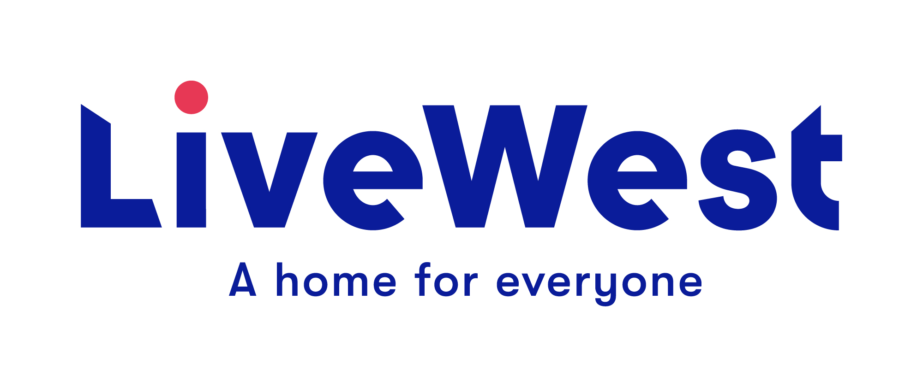
Small Grant Application Form
for Groups

This application form is for grants to support organisations responding to Covid-19 in ways that directly impact on our customers. Grants are to cover specific costs or needs of organisations and activity must demonstrate it includes our customers.

- Name and contact details of applicant:

Name of group/organisation:

Address:

Contact Number:

Email address:

Name of person completing this form and your position in the group:
Name of LiveWest member of staff completing form (if applicable):

- Purpose of the funding – Please explain what you will use the funding for:

- Amount applied for:
We are keen to spread our support as widely as possible and will be giving small repeated donations based on need and how this is benefiting LiveWest Residents.  If you have a specific requirement, please explain how much are you applying for? | Item/service Cost  £  £  £  £  Total £  Income from any other sources? £
Bank Details:  If your application is approved, we will send payment by BACS transfer. | Account Name:  Account Number:  Sort Code:  Organisational contact for us to verify bank details:

- Details of your organisation – How long has it been running, what is its core work, and does it have a history of working with LiveWest?
☐Local community group ☐Registered Charity
☐Residents Association ☐Limited Company
☐Community Interest Company ☐ Other

Registered number if applicable_______________________
Other information:

5 Where will the project, activity or event take place, how will it include LiveWest customers, how many people do you expect it to benefit and what proportion of those will be LiveWest customers? Is your project targeted at any specific age range or groups such as elderly people, people self-isolating or families?

6 How have you identified the need for it? If anyone else is running a similar project locally, how will you work with them to compliment your work or prevent duplication?

7 Please explain any other funding you have received?

8 Please provide any other information relevant to your application:

9 It is important we target our support to benefit LiveWest customers. Please can you explain how you will monitor and record this?

Please email completed application to - grants@livewest.co.uk

General Data Protection Regulation

LiveWest is subject to the requirements of The General Data Protection Regulation, please see our website for our current Privacy notice.

By signing this proposal form, you agree to the following:

1. We will use this application form and the other information you give us for the following purposes only:
- To decide whether to support your activity or project with LiveWest funding
- To hold in our database and use for statistical purposes and future monitoring of the project.
- By writing your name on this form and submitting it to LiveWest, we can take this as consent for us to hold the data provided and use it for the purpose it was given.

2. LiveWest reserve the right to withdraw any application

In submitting this application, you confirm that, to the best of your knowledge, the information provided on this form is correct and you confirm that any grant awarded will be used exclusively for the purposes described.

Signed____________________________________________________

Date____________________________

