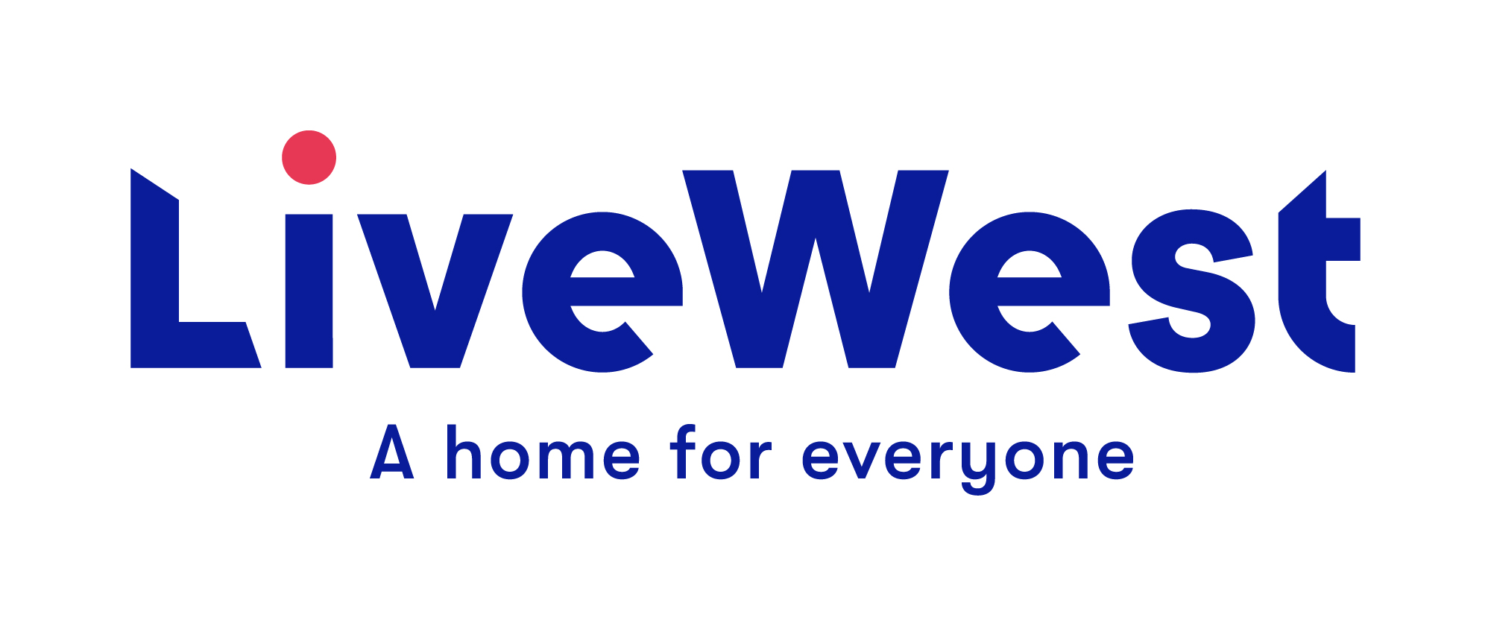
Small Grant Application Form
For Groups

This application form is for Grants of up to £1,000
Improvement Fund - Application
LiveWest Small Grants for groups can be applied for by projects which will benefit LiveWest communities and have resident involvement and commitment to the project.

- Name and contact details of applicant:

Name of group/organisation:

Address:

Contact Number:

Email address:

Name of person completing this form and your position in the group:
LiveWest member of staff name: (If a LiveWest member of staff has submitted the application on behalf of a group). Please note this member of staff will need to complete question 22.

- Have you previously applied to LiveWest for funding?
If so when did you apply and what was the outcome?

- Amount applied for:
How much are you applying for? | £  Please provide a breakdown of costs in section 15.
If your application is approved we will send payment by cheque. Please state who the cheque should be made payable to. (If there is any problem with being paid by cheque, please explain here.)

4 Purpose of the funding - Please explain what you will use the funding for:

5 Where will the project, activity or event take place, how will it include LiveWest residents, how many people do you expect it to benefit and what proportion of those will be LiveWest residents?

6 Project timeline:

Start date:
End date:
Key Milestones:

7 What are the reasons for your project, event or activity and how have you identified the need for it? If anyone else is running a similar project locally, how will you work with them to compliment your work or prevent duplication?

8 What do you want to achieve from this project? Please list the aims of your activity

9 Is your project targeted at any specific age range or groups such as people on low incomes, asylum seekers, unemployed people etc.?

10 Please give details of any other agencies, organisations or partners who will be involved?

11 Is your project, event or activity dependent on anyone or anything else? E.g. permissions, recruiting individuals.

12 ‘In kind’: please show the ‘in kind’ support the project will attract
E.g. Gifted items, volunteer time etc.

13 How will your project, activity or event be advertised and promoted? Will you be requiring any assistance from LiveWest with this?

14 How and when will you measure and demonstrate that you have achieved the aims of your project, activity or event and whether it has been a success? It is a requirement of being awarded a grant by LiveWest that you will undertake monitoring and evaluation of your grant and share this with LiveWest.

15 Costings: Please provide details on the costings for your project, event or activity and attach any supporting evidence:
Item/service | Cost
 | £
 | £
 | £
 | £
 | £
 | £
 | £
Total | £
Income from any other sources? | £

16 If you are applying for funding from any other sources please state where from, how much has been applied for and whether the funding has been awarded, or if the application is pending:

17 What type of organisation are you?
☐Local community group ☐Registered Charity
☐Residents Association ☐Limited Company
☐Community Interest Company ☐ Other

Registered number if applicable_______________________
If you have a constitution or governing document, please provide a copy with your application.

18 Please explain your group or organisation, how long it has been running, what is your main purpose and what are your main activities?

19 Do you have any paid staff? If so, how many and what are their job roles/titles?

20 Do you have any of the following:
 | Yes | In hand | Not Required
Public liability insurance | ☐ | ☐ | ☐
Equality and diversity statement | ☐ | ☐ | ☐
Child protection policy | ☐ | ☐ | ☐
Safeguarding policy | ☐ | ☐ | ☐
DBS (formerly CRB details) | ☐ | ☐ | ☐
Food hygiene certificate | ☐ | ☐ | ☐
Risk assessment(s) | ☐ | ☐ | ☐
Permissions to use photographs/publicity | ☐ | ☐ | ☐

21 Financial Details:
Please supply your latest financial statement or current bank account balance, details of annual turnover,
If applicable and details of any major assets, which includes vehicles, IT equipment etc.

22 LiveWest member of staff comments
Please provide any further information to support the application.
Including area insight information (LiveWest properties in the area etc)

23 Postcode/s: please state the postcode/s the project covers.

24 Where did you hear about LiveWest Grants

Our website
Social media
LiveWest colleagues
Word of mouth

Please email completed application to - grants@livewest.co.uk

Please note that a decision can take approximately 4 weeks.

General Data Protection Regulation

LiveWest is subject to the requirements of The General Data Protection Regulation, please see our website for our current Privacy notice.

By signing this proposal form, you agree to the following:

1. We will use this application form and the other information you give us for the following purposes only:
- To decide whether to support your activity or project with LiveWest funding
- To hold in our database and use for statistical purposes and future monitoring of the project.
- By writing your name on this form and submitting it to LiveWest, we can take this as consent for us to hold the data provided and use it for the purpose it was given.

2. LiveWest reserve the right to withdraw any application

In submitting this application you confirm that, to the best of your knowledge, the information provided on this form is correct and you confirm that any grant awarded will be used exclusively for the purposes described.

OFFICE USE:

Application Ref No.

Date received

Applicant Name

Grant requested

Have they already been awarded a grant this financial year?
Impact data received?
Decision

Date decision made

Comments

How was application received? Website/ staff referral

