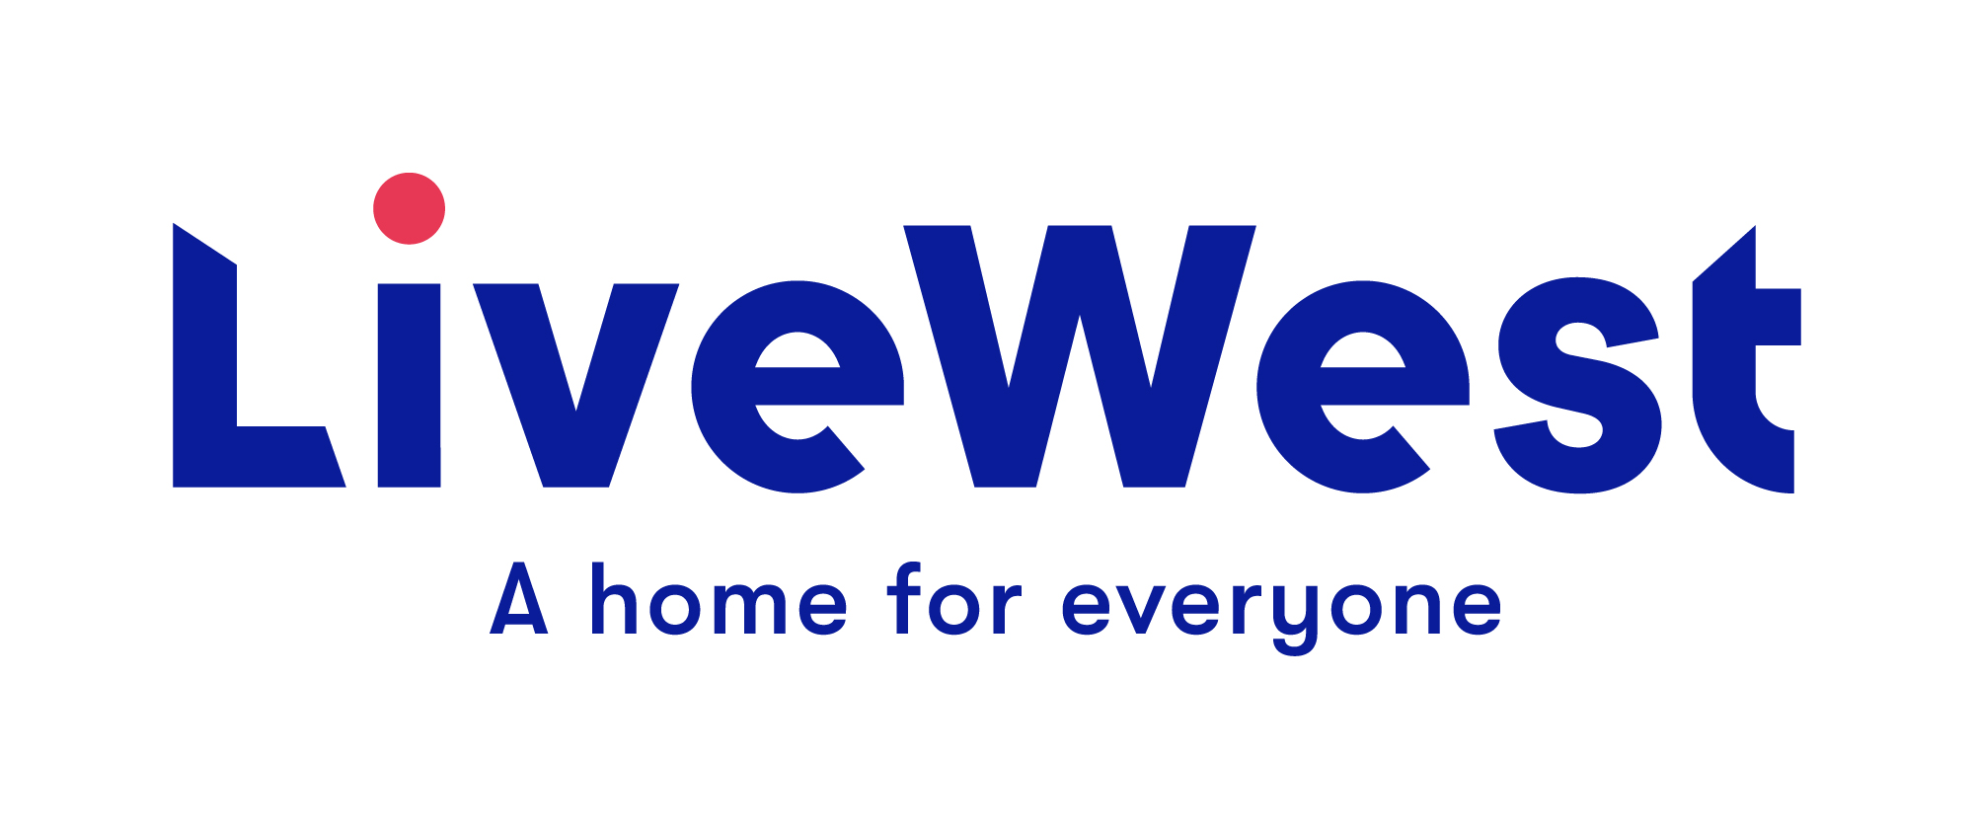
Resident Opportunity Fund Application Form
For Individuals

This application form is for grants of up to £500.
Improvement Fund - Application
The LiveWest Resident Opportunity Fund is for LiveWest residents only and aims to support individuals improve their employment and education prospects, health and wellbeing or personal development.

- Name and contact details of applicant:

Resident Name:

LiveWest Member of Staff:
Name of staff member supporting this application
Resident Address:

Resident Contact Number:

Resident Email address:

- Have you previously applied to LiveWest for funding?
If so when did you apply and what was the outcome?

- Amount applied for:
Please provide a breakdown of cost in section 6. | £
If your application is approved we will normally send payment by cheque. Please state who the cheque should be made payable to. (If there is any problem with being paid by cheque, please explain here.)

4 Purpose of the funding - Please explain what you will use the funding for.

5 When do you propose to use the funding if successful? E.g. when is the course start date?

6 What difference will the money make to you and your future?

For example:
- How will the training course enable you to find employment?
- How will you sustain a new business when the grant funding is spent?

7 Costings:

Please provide details on the costings and attach any supporting evidence
Please note that if your application is successful LiveWest will require copies of receipts in relation to these costs.
LiveWest will award a maximum of £250 for laptops and software.

Item | Cost
 | £
 | £
 | £
 | £
 | £
Total | £
Any other funding or contributions | £
Total funding being applied for from LiveWest | £

8 Grants for training courses:

Please provide details of the course provider (name of course, dates, and contact information for invoicing)

9 What steps have you taken to achieve your goals outside of LiveWest funding? Have you attempted to gain funding from other sources, if so where and what is the result? Have you undertaken other training or related courses? Please explain any related activity or preparatory work.

10 Summary:
Please provide any additional information to support your application.

For business start up’s please include details of turnover, projections and market research. You can attach a business plan if you have one, details of Public Liability Insurance, Food Hygiene Certificate and Risk Assessment(s) if applicable.

11 Local Authority: Please state which Local Authority area you live in

12 Your current employment status:

13 Income/ Expenditure: Please provide details of monthly household income and expenditure.

Income | £ | Expenditure | £
Applicant wages |  | Rent/ Mortgage
Partner wages (if applicable) |  | Council Tax
Universal Credit |  | Water
ESA |  | Gas
JSA |  | Electricity
Child Tax Credit |  | TV Licence
Working Tax Credit |  | Housekeeping
DLA/AA/PIP |  | TV/Phone
Child Benefit |  | Other expenditure
Housing Benefit
Income from non-dependents
Other income
Total | £ | Total | £

14 LiveWest member of staff comments
Please provide any further information to support the application.

15 Where did you hear about LiveWest Grants

Our website
Social media
LiveWest colleagues
Word of mouth

Resident Signature: (For digital applications a name here will be taken as signature)

I confirm that I have read and understood the information provided within the guidance notes and agree to the terms and conditions. The information I have supplied on this form is true and accurate to the best of my knowledge and correct at the time of writing. I authorise LiveWest to process the information in this application as described.
Please email completed application to: grants@livewest.co.uk
Please note that a decision can take up to 4 weeks from the deadline date of the first Tuesday of each month.

General Data Protection Regulation
LiveWest is subject to the requirements of The General Data Protection Regulation, please see our website for our current Privacy notice.

By signing this proposal form, you agree to the following:

1. We will use this application form and the other information you give us for the following purposes only:
- To decide whether to support your activity or project with LiveWest funding
- To hold in our database and use for statistical purposes and future monitoring of the project.
- By writing your name on this form and submitting it to LiveWest, we can take this as consent for us to hold the data provided and use it for the purpose it was given.

2. LiveWest reserve the right to withdraw any application

In submitting this application you confirm that, to the best of your knowledge, the information provided on this form is correct and you confirm that any grant awarded will be used exclusively for the purposes described.

OFFICE USE:

Application Ref No.

Date received

Rent statement check

Tenancy check

Previous funding from LiveWest

Grant requested

Comments

Decision & date

Cost Code/s & payment method

